Features list of Record Management module:
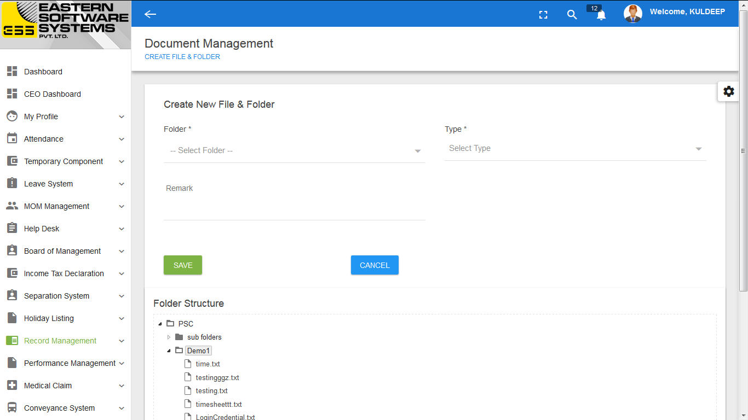
- There is Record Unit which contain the record(files) by separated folder.

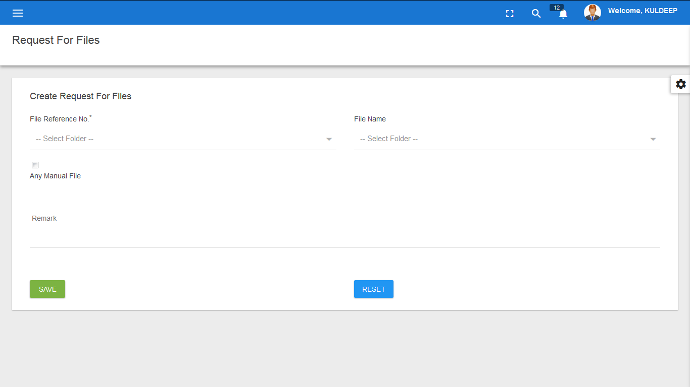
- End User can send the request for record(files) to Record Unit to get the file .

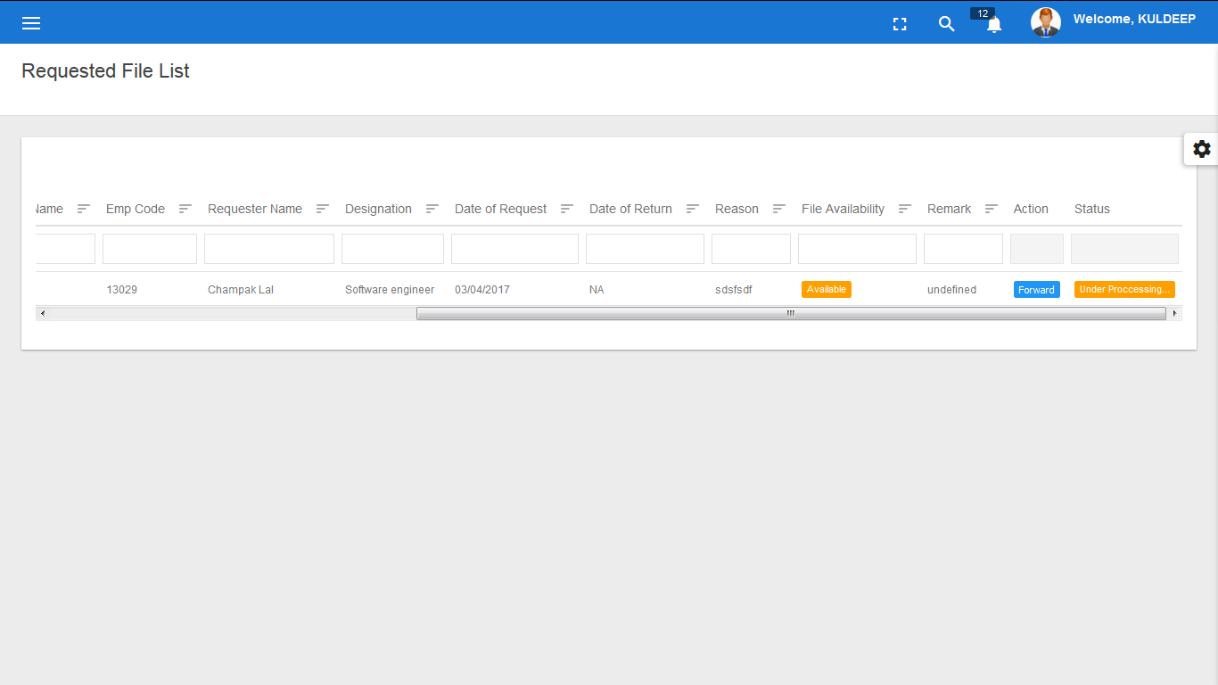
- Record Unit will check the availability and forward that File to requested user.

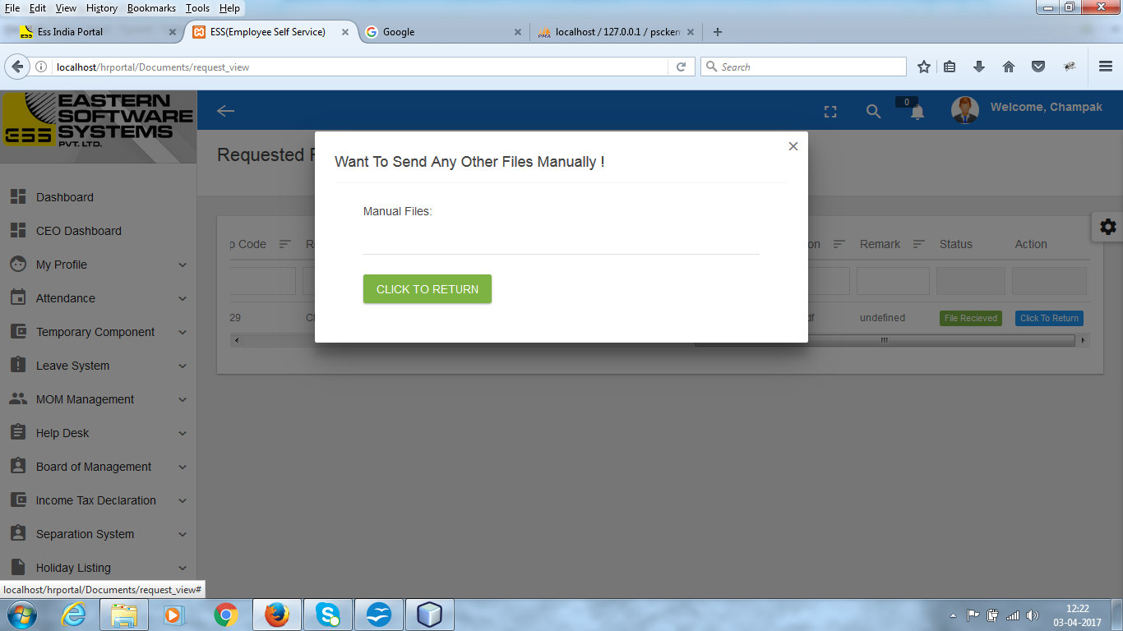
- Requested user will revert that file to Record Unit after completed the work on that file.

Features list of Conveyance System module:

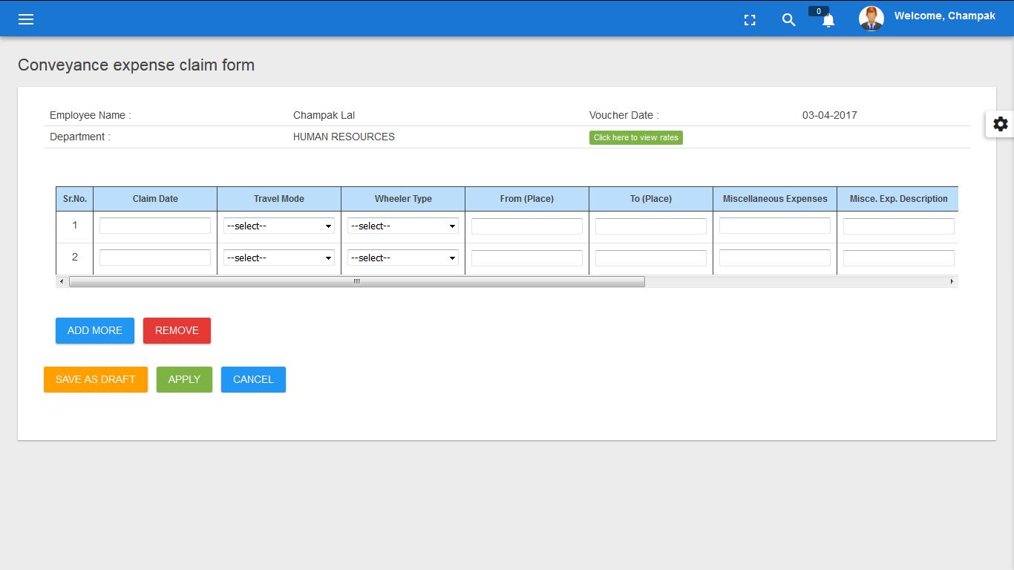
- In conveyance system, user will fill the conveyance voucher.

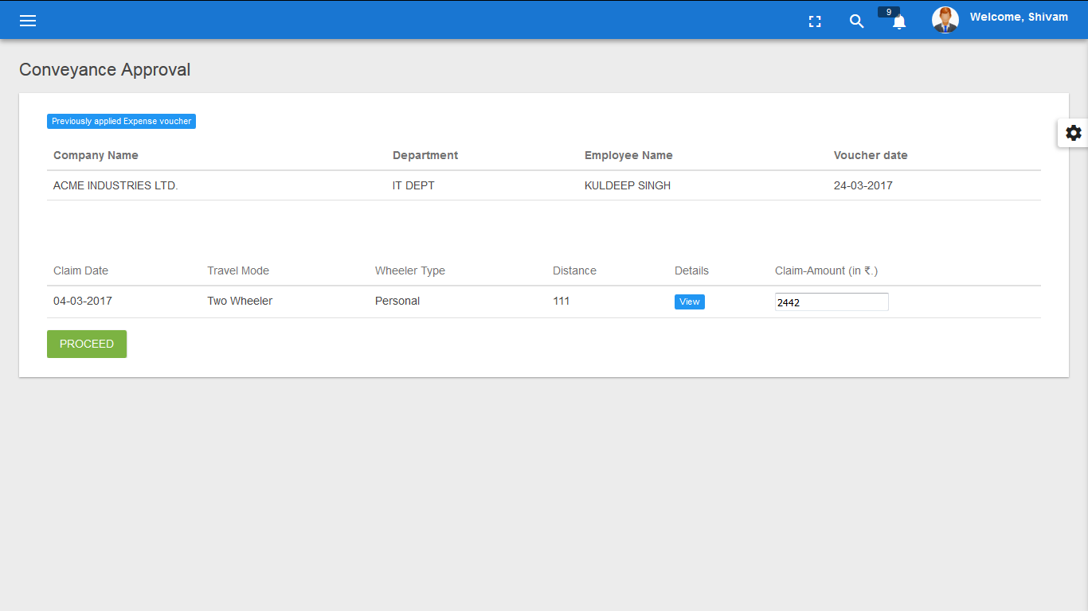
- Voucher will approved by manager at two level.

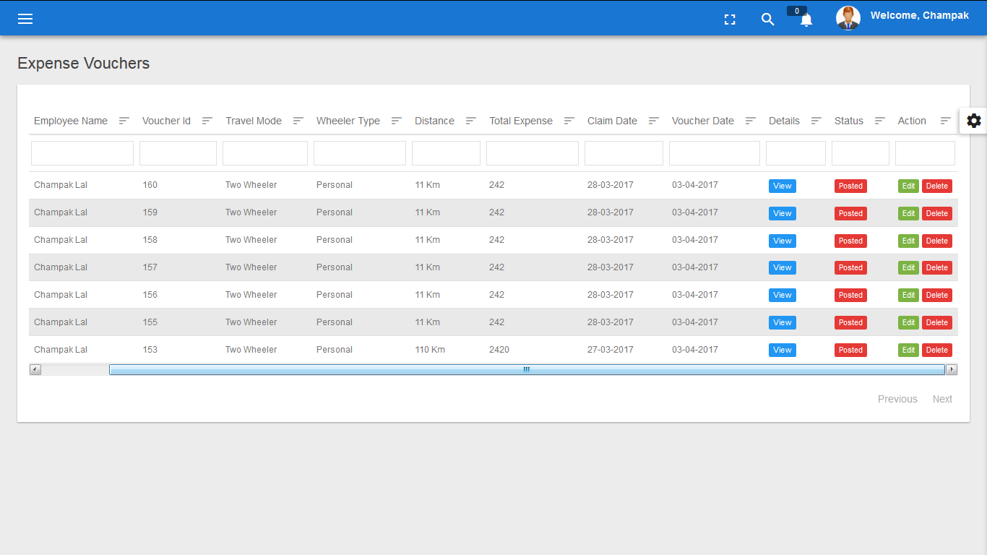
- User can check the status of voucher in view list.

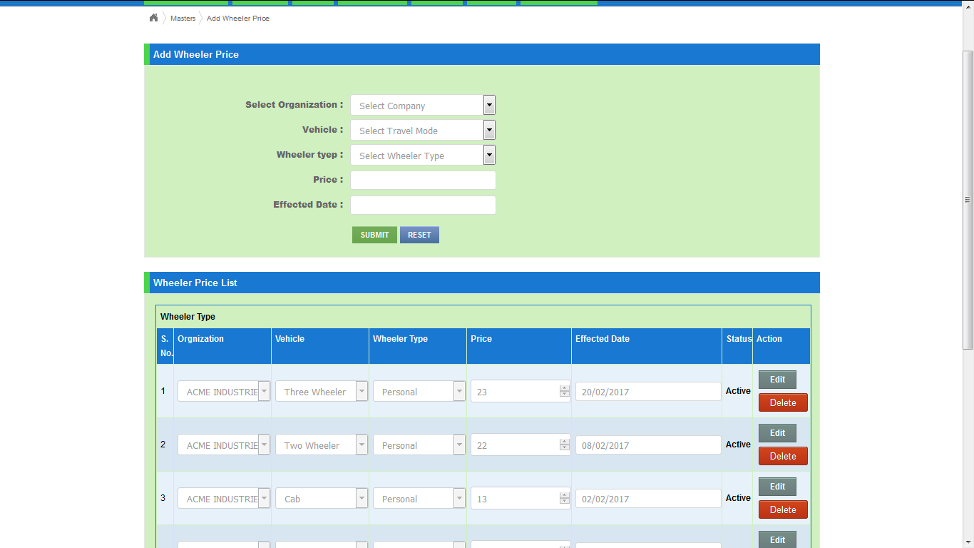
- We can create the travel mode and wheeler type by admin panel .

Features list of Travel Expenses module:
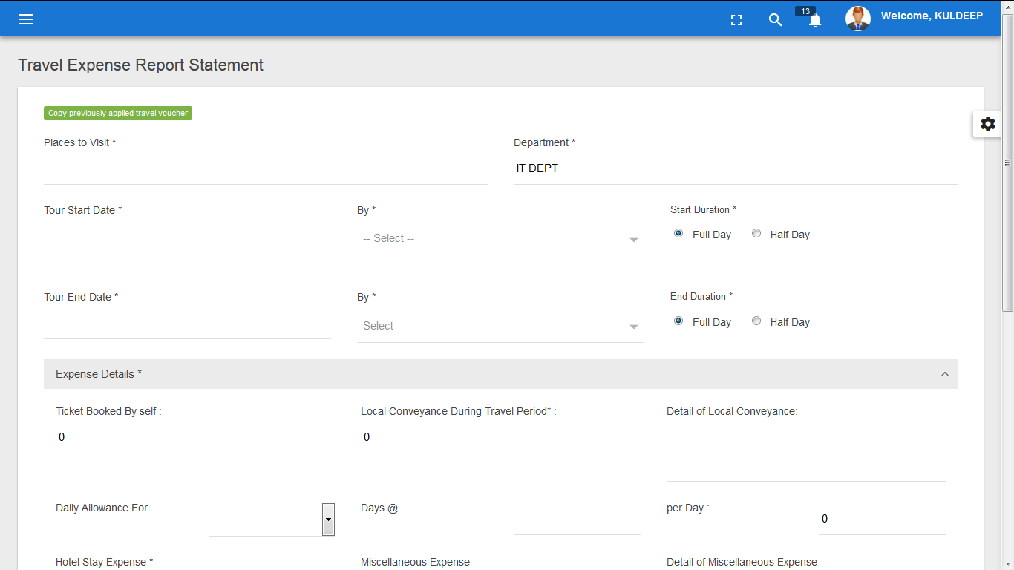
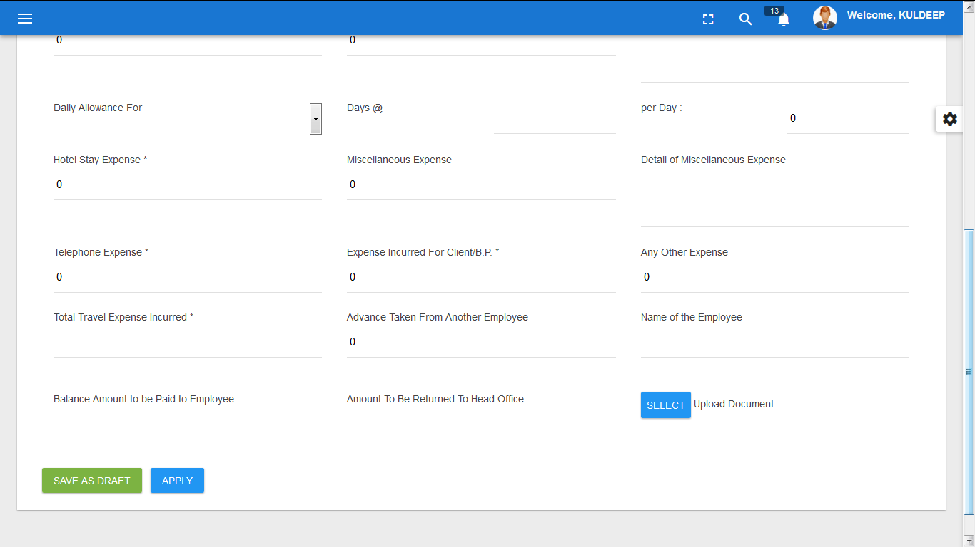
- In travel expenses , user will fill the conveyance voucher.

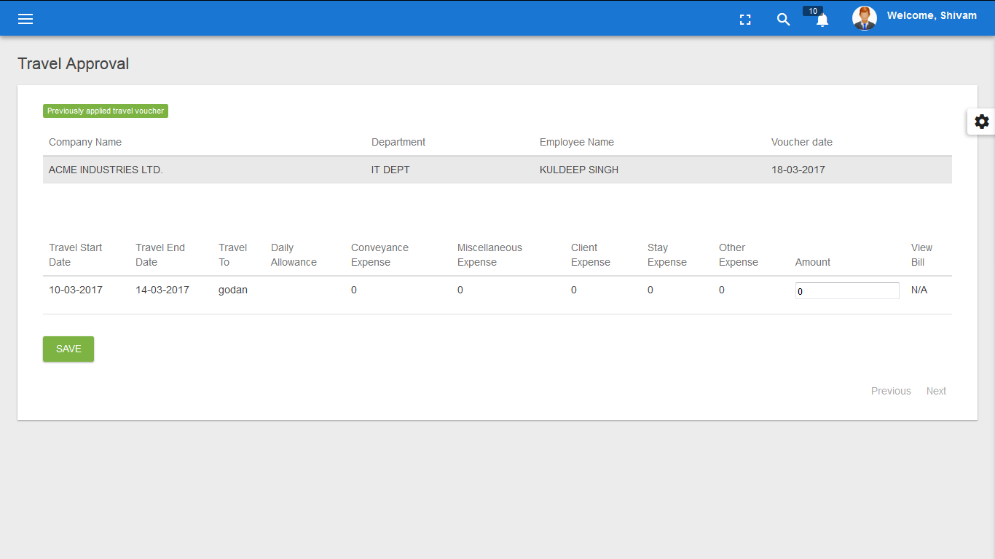
- Voucher will approved by manager at two level.

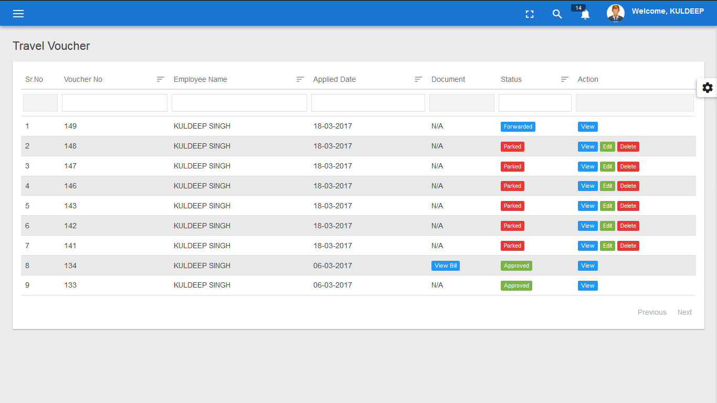
- User can check the status of voucher in view list.

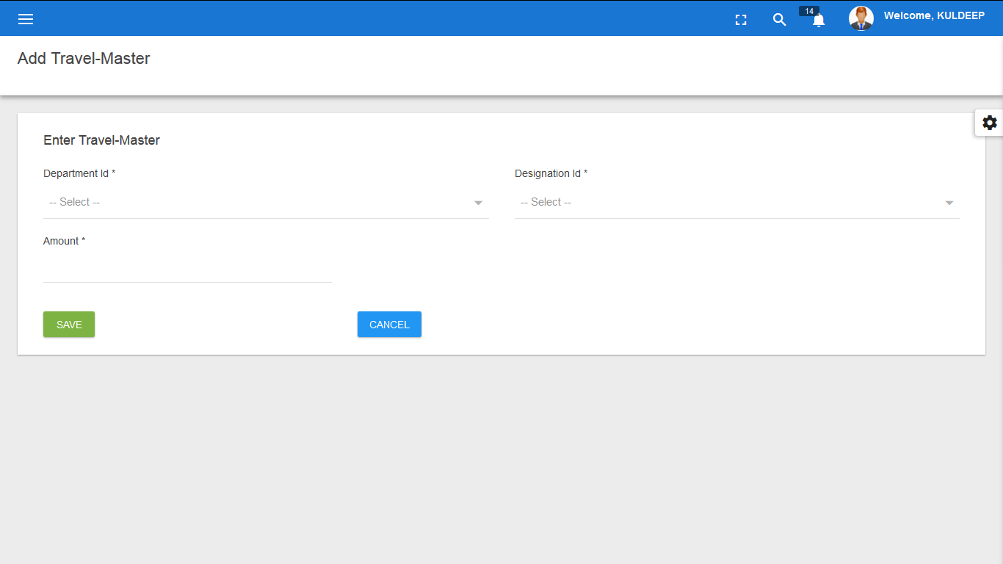
- There is window to enter daily allowance amount.

Features list of Legal Management module:
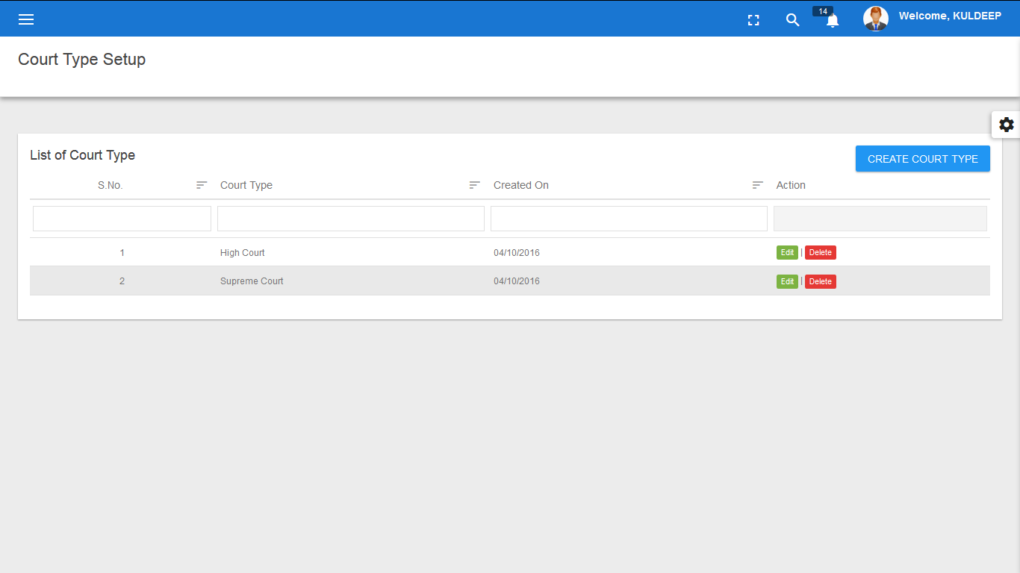
- Court Type Master, Case Type Master, Case Status Master, Case Outcome Master, Court Location Master.

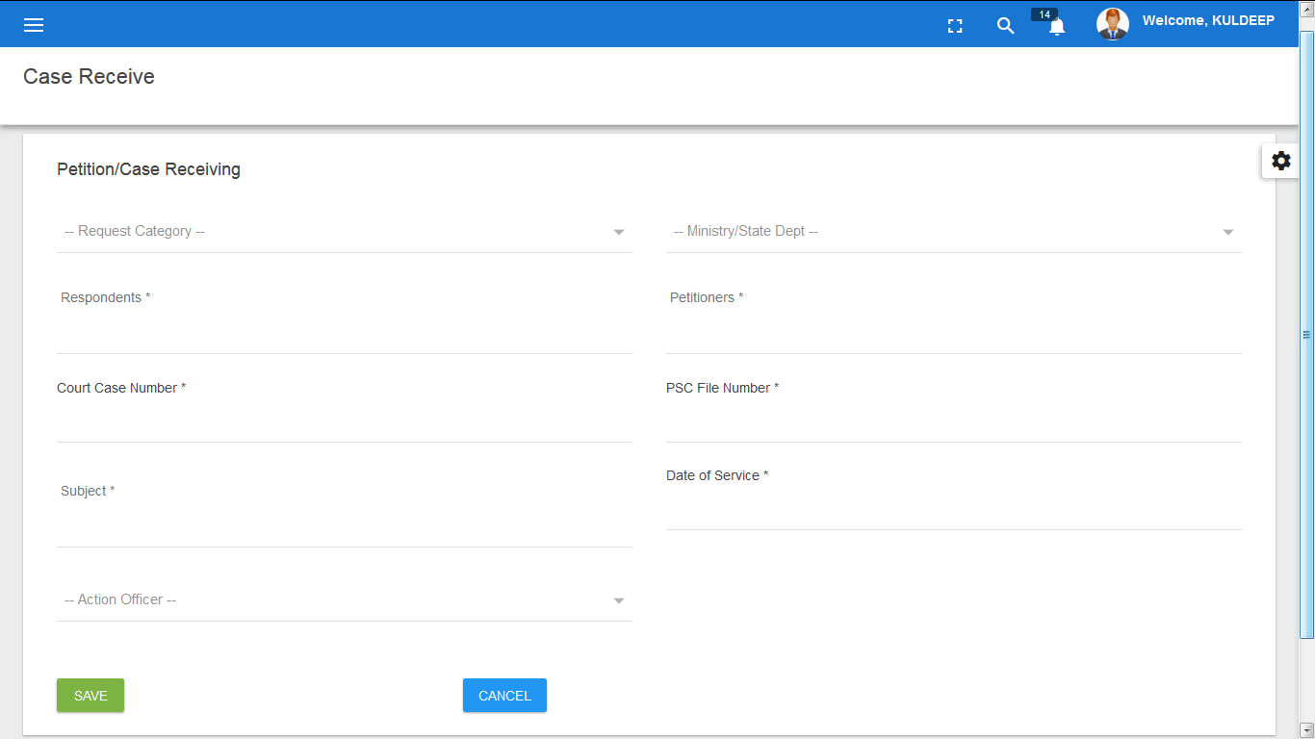
- There is provision to enter the case receiving.

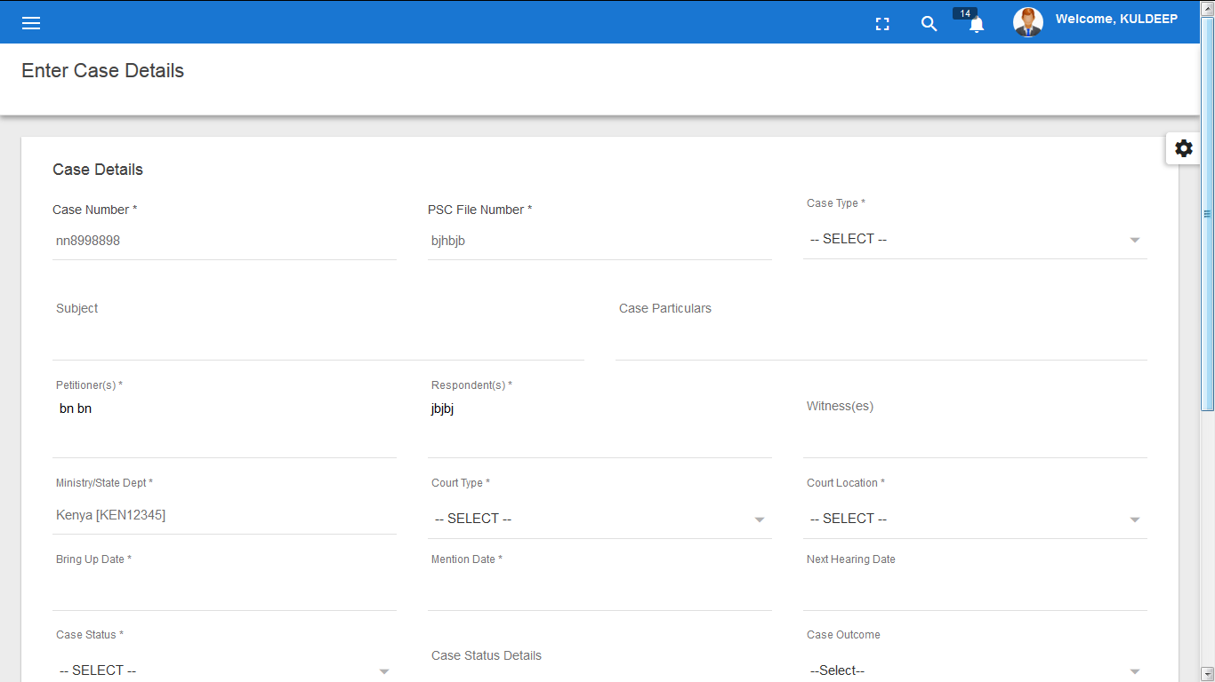

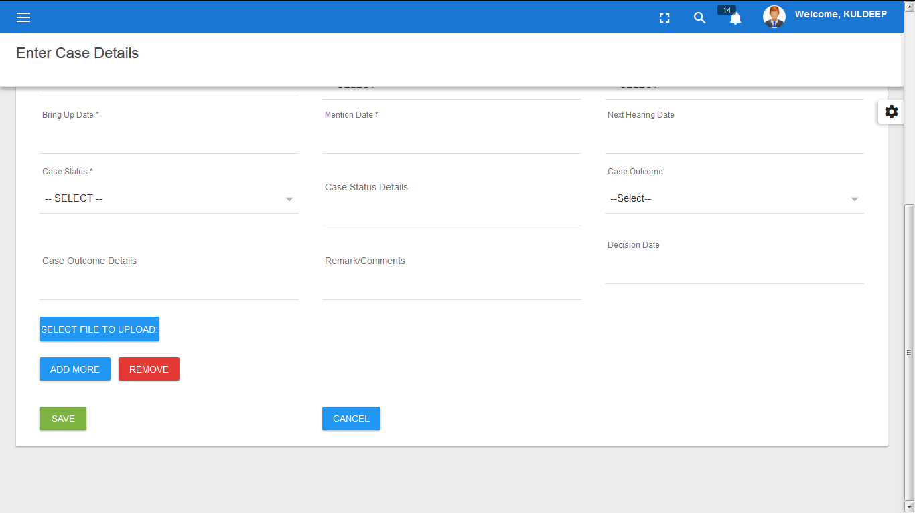

- There is provision to enter the case details after and before hearing.

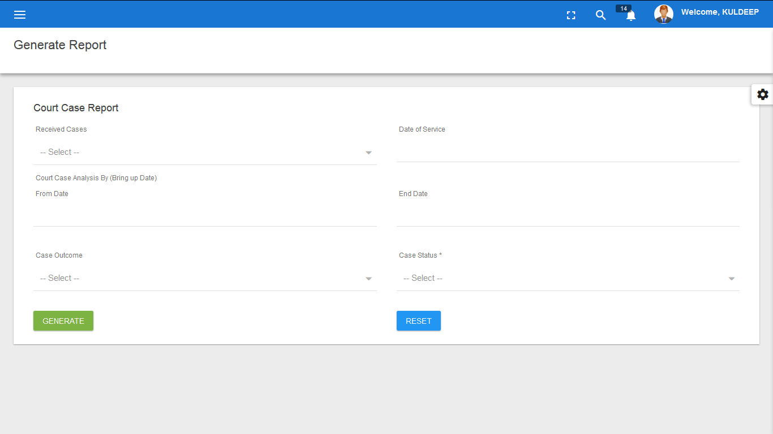
- Reports

Features list of Board Management module:

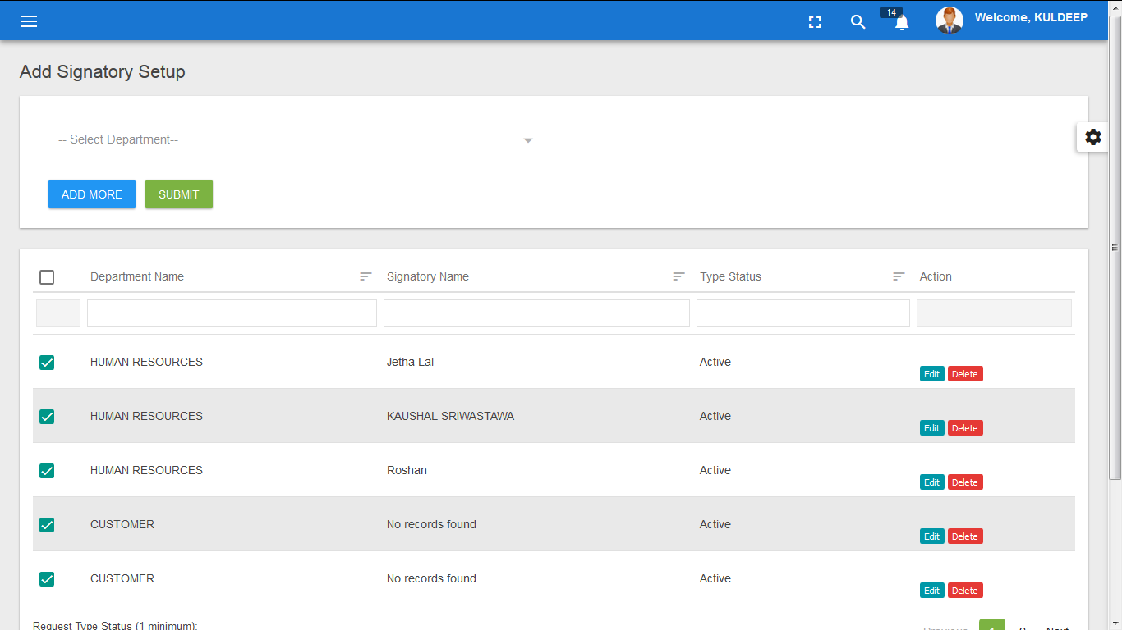
- There is window to create the Signatory Master,Ministry Master, Request Type Master, Job Code Master,Data Type Master.

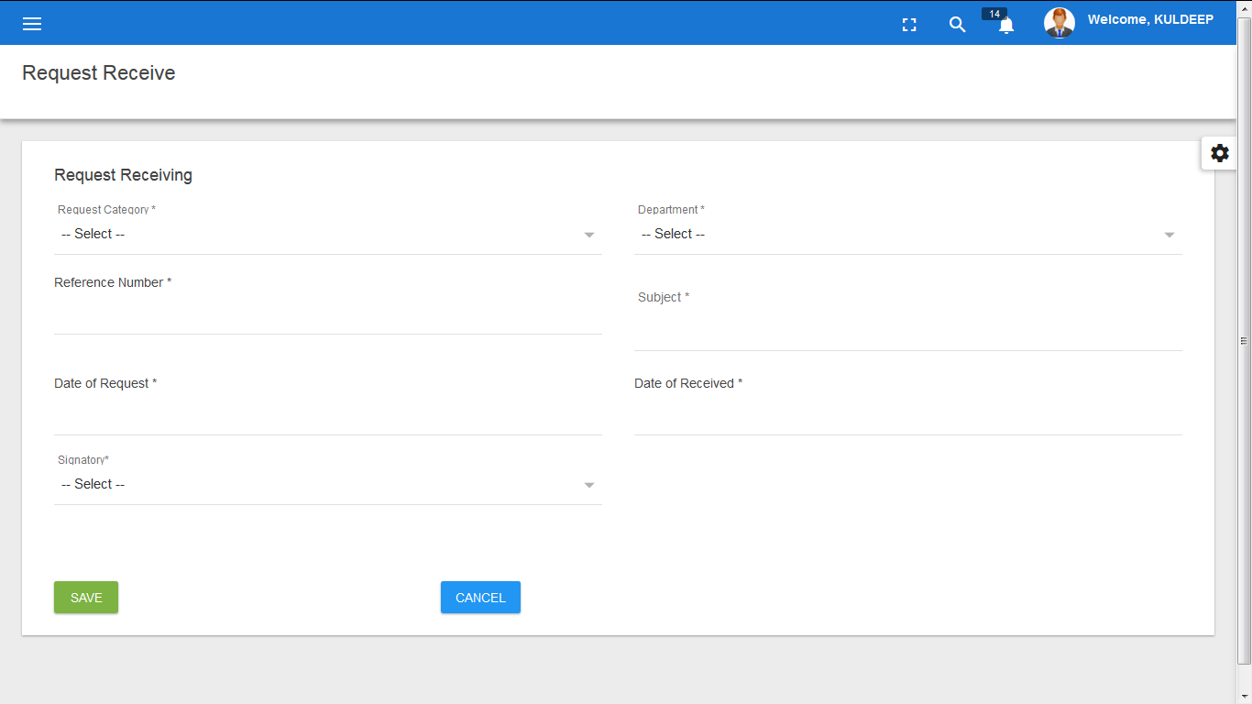
- User “A” can create the request for details(any detail) to User “B”, then user “B” will get the window to fill the requested details.

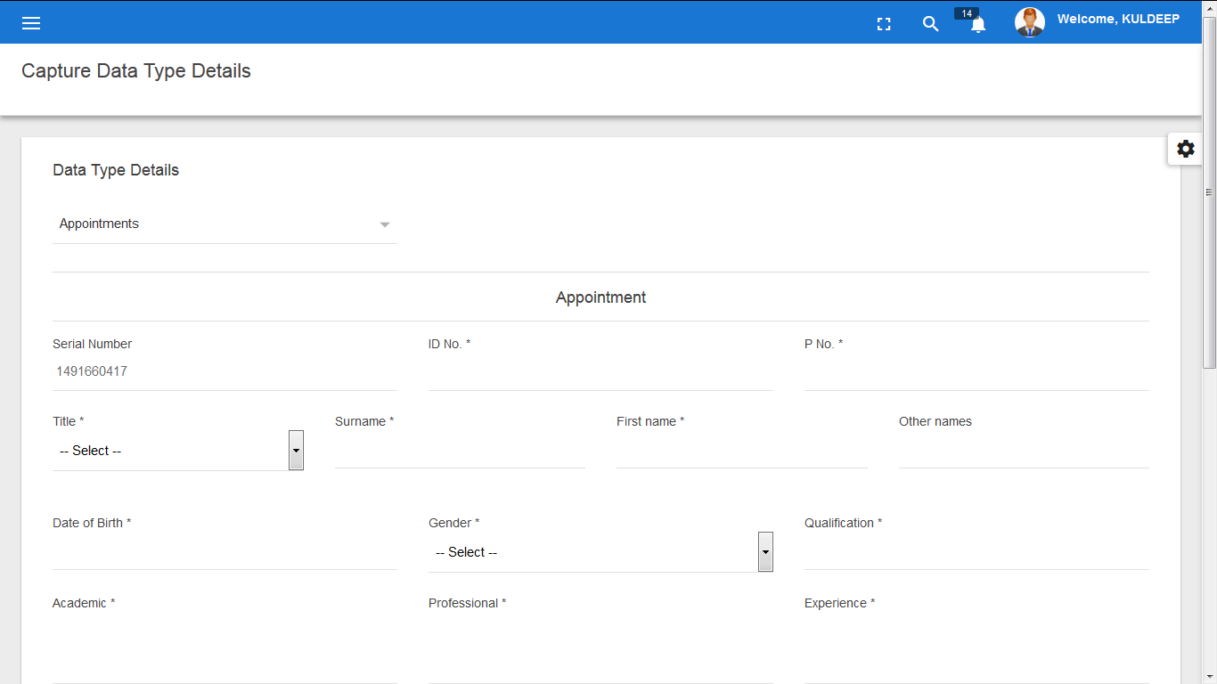
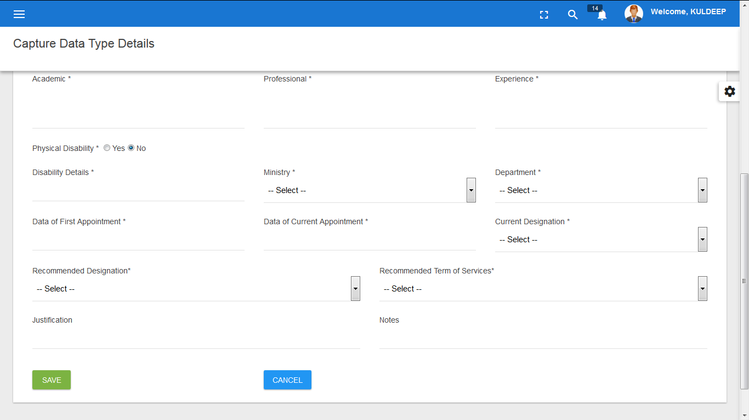
- Window to capture the data type details.

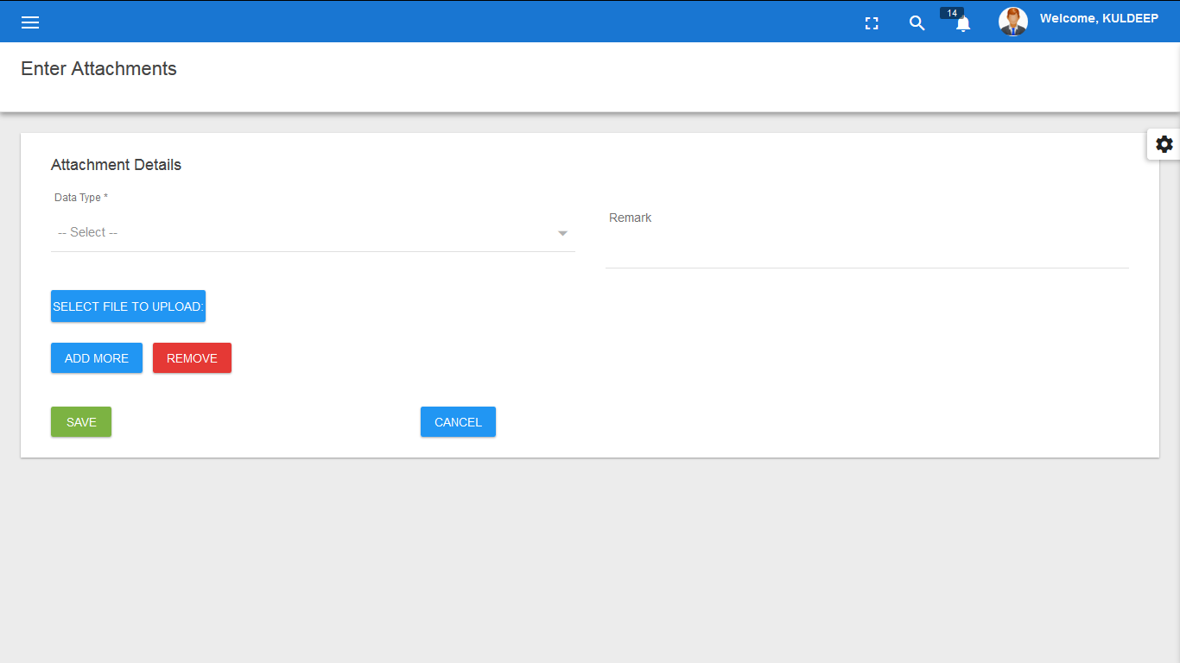
- Window to capture report type attachments.

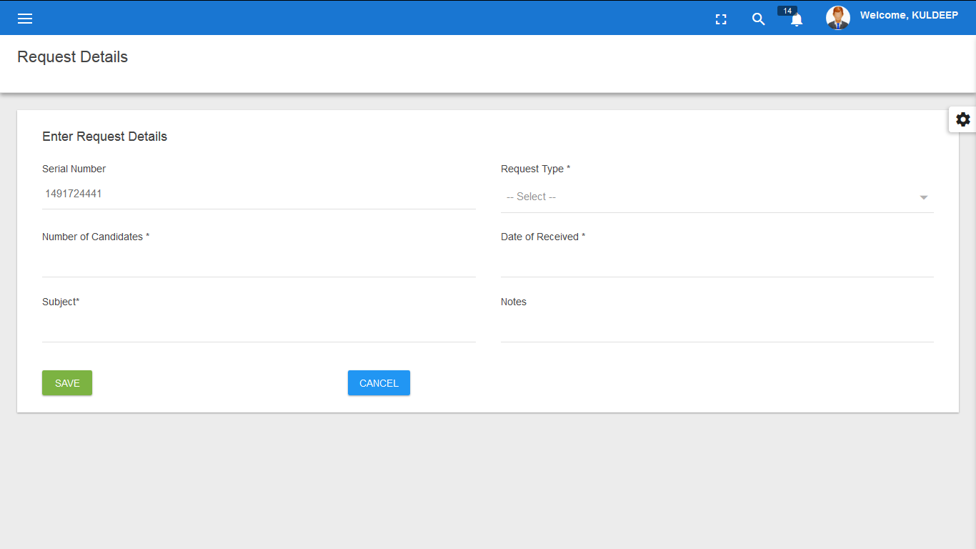
- Recruitment Finalization.

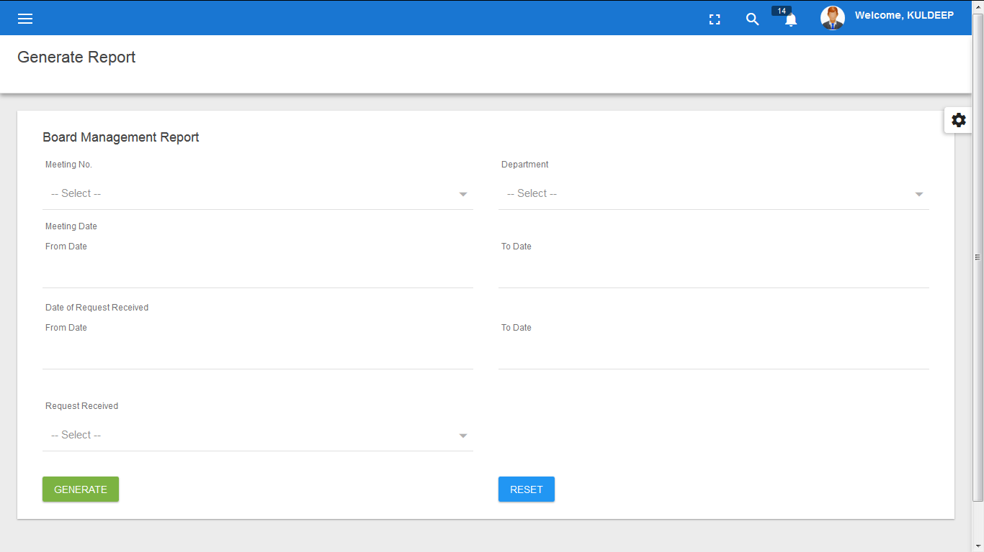
- Reports

